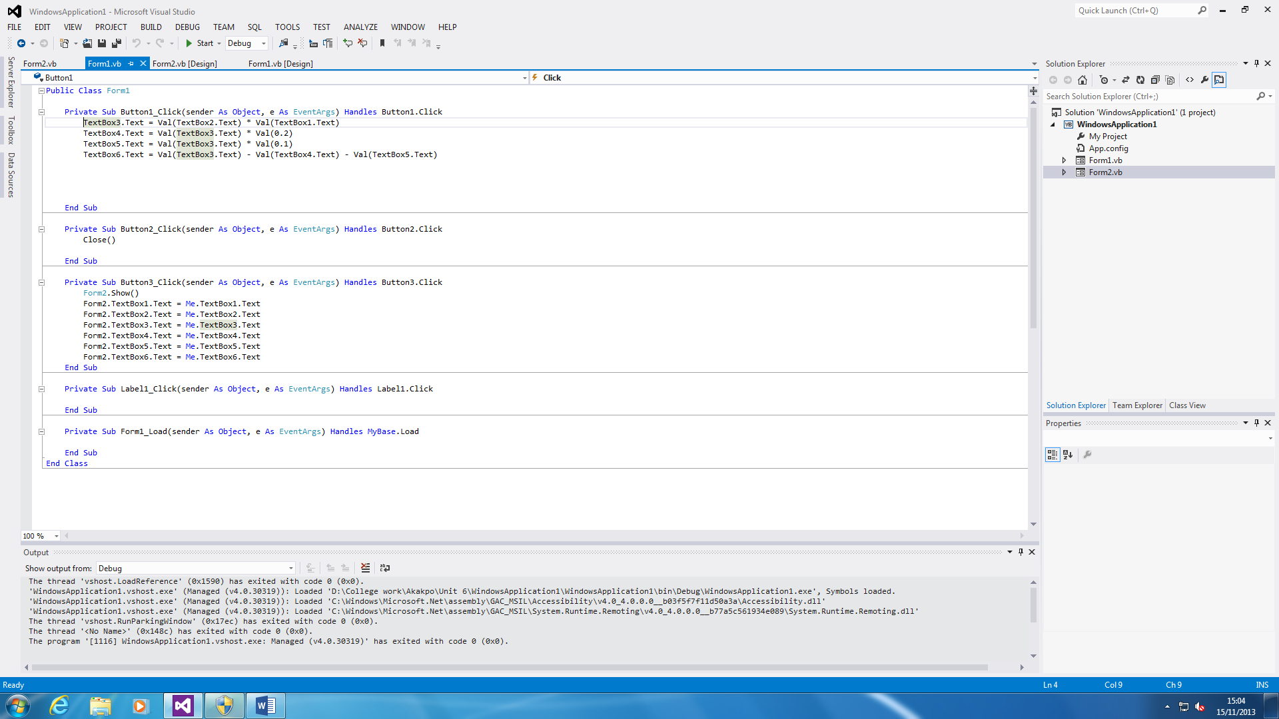

**CODES**

These are all the codes of the calculations that are inserted. Without these, the calculator will not work.

This code transfers all the answers from form 1 to form 2. Therefore, they can print it out.

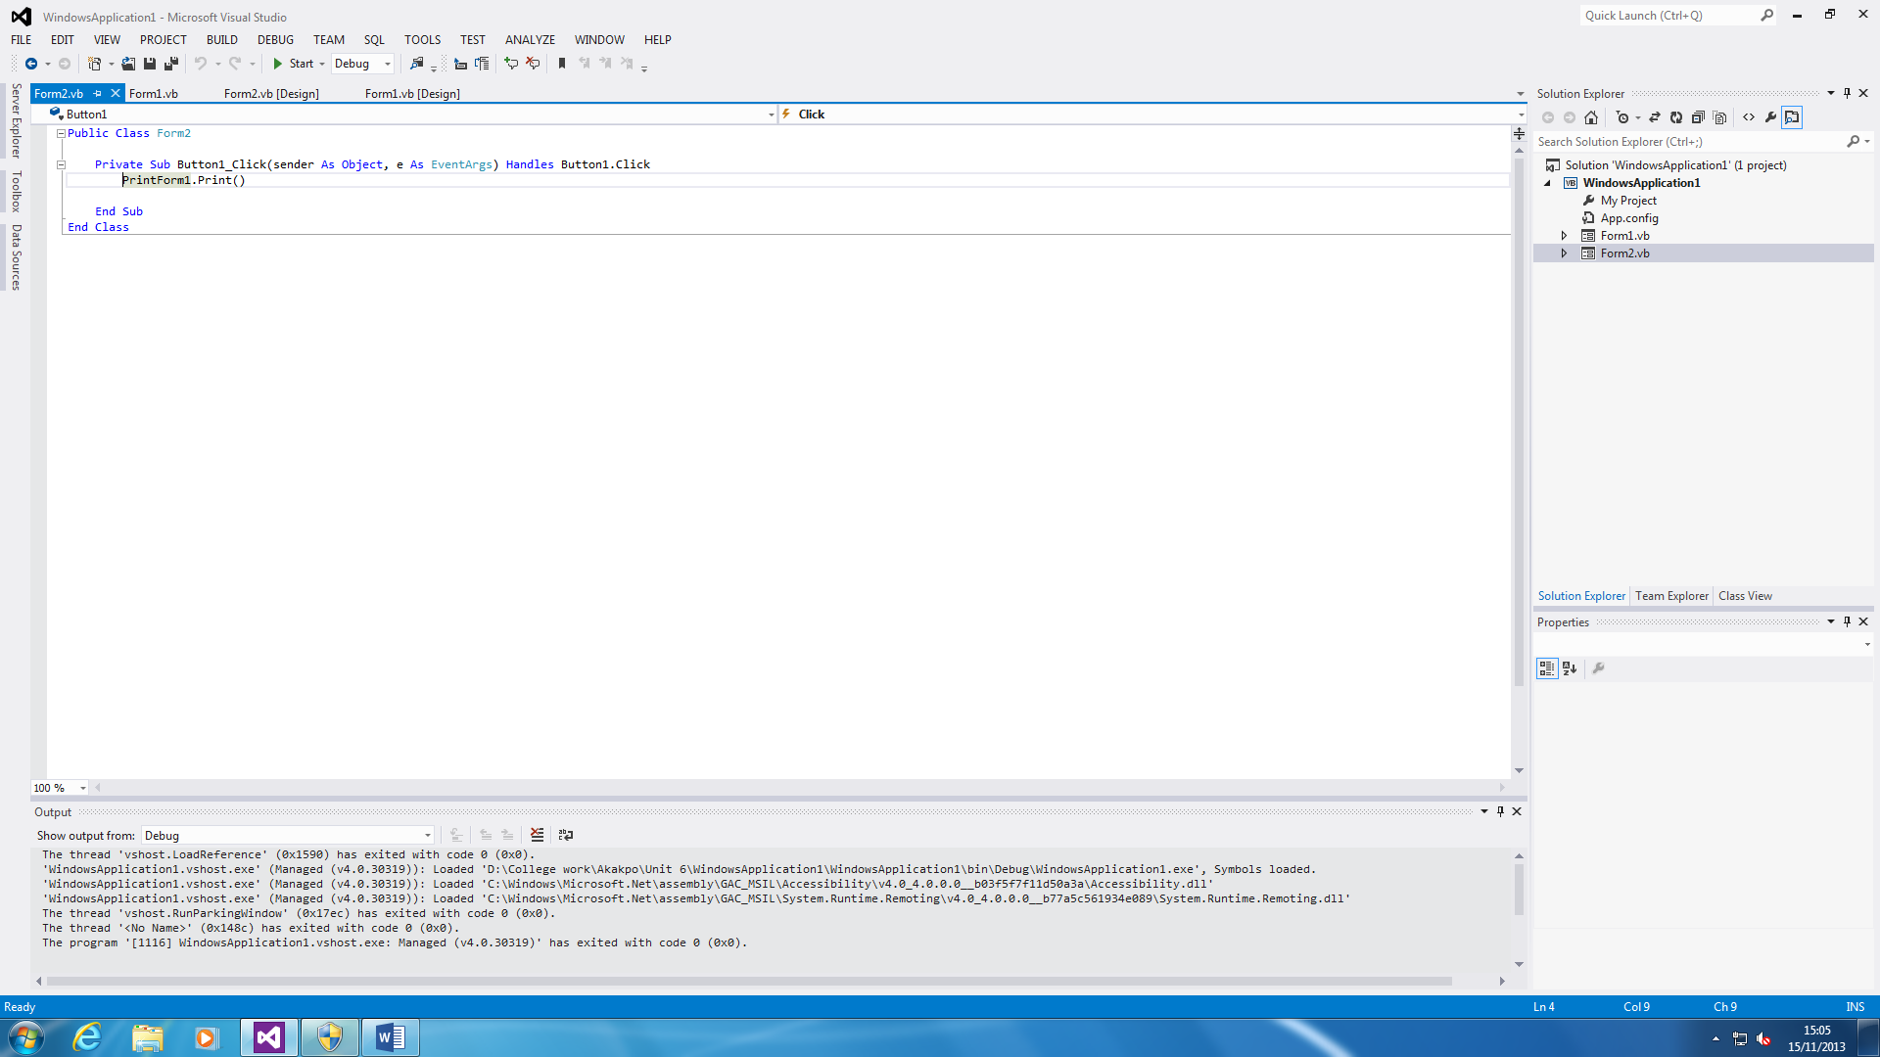

This prints out the second form once the button is pressed.

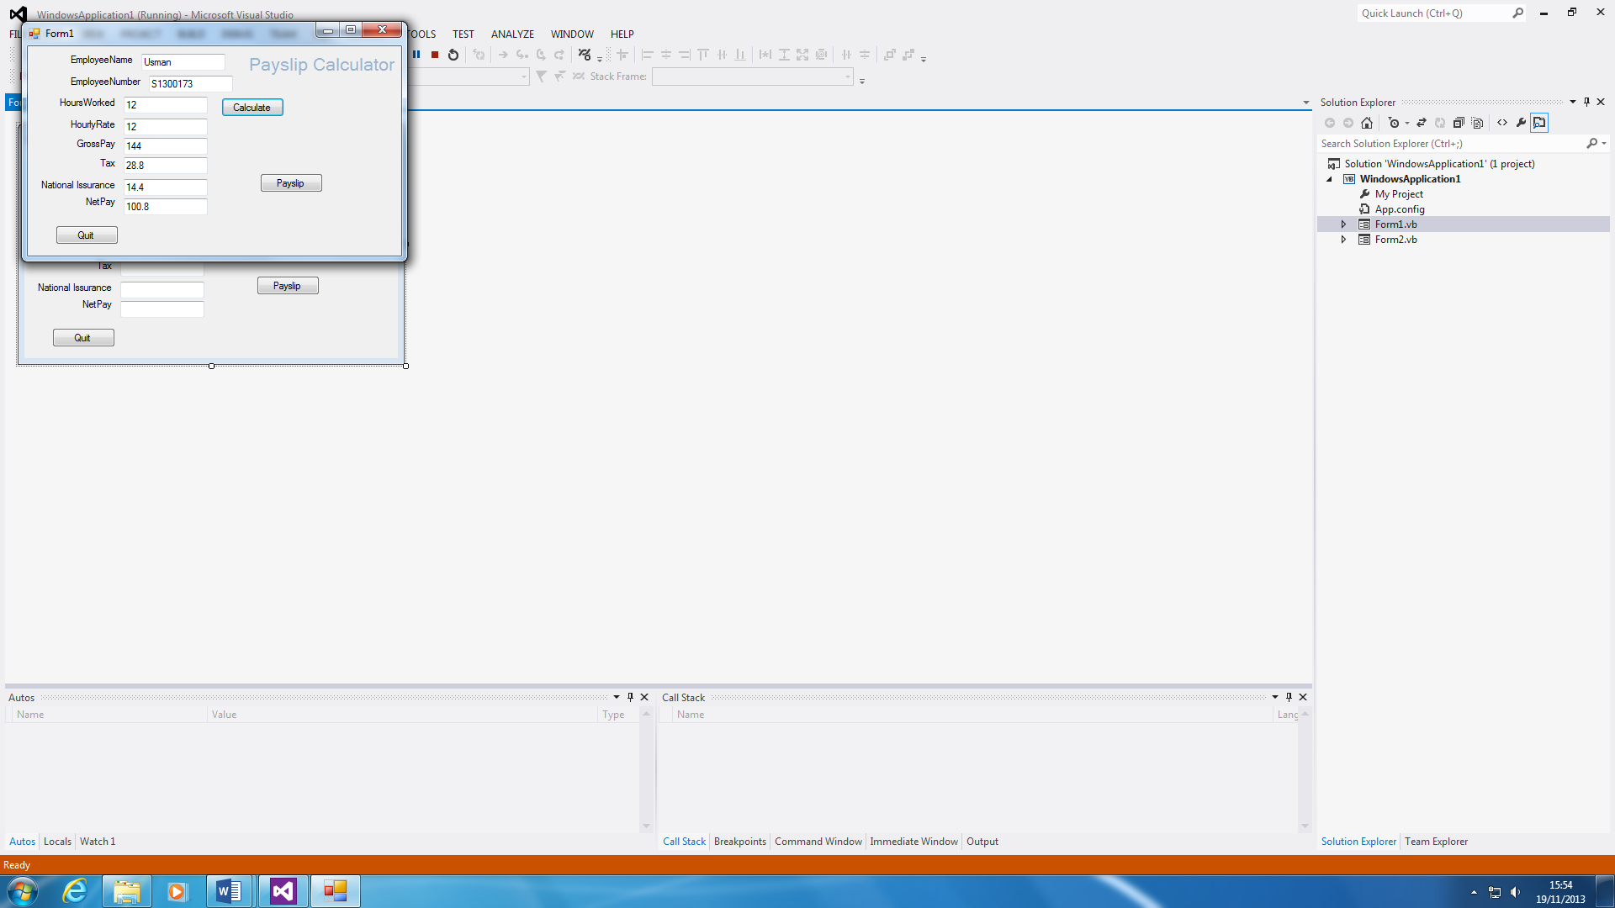My program satisfies task 1, because it follows all the steps that have been asked. For example, the picture below. It follows all the steps that have been asked. For example, I inserted 12 in each box of HoursWorked and HourlyRate. This gave me the answer of 144, which was required on task 1. As you can see the diagram on the diagram, it multiples both 12 together which is the correct answer; the tax is 20% of 144. Also, the one thing that you have to notice is that I pressed the ‘calculate’ button for this to happen which is the whole basics of the programme, to be done by itself. The answer is obviously correct. This is vital, because GrossPay variable is inserted in every single calculation. If the code is wrong, the programme calculation will be wrong.

|  |  |  |
| --- | --- | --- |
| Variable Names | Data Type | Comments |
| EmployeeNumber | Integer | This is important, because it will identify which employee. For example, S1300173. This includes numbers and texts. |
| EmployeeName | Character | You have to type your name in to identify who you are. This can be any type of name such as Obama. |
| HourlyRate | Real | This variable is important because if this is not entered, the program will not calculate the NetPay. For example, £10.75 per hour. |
| HoursWorked | Real | HoursWorked is as important as HourlyRate. If this is not entered, it will not be calculated. |
| National Insurance | Real | National Insurance is important as this as others gets calculated. This will get worked out, same as others. |
| GrossPay | Real | GrossPay is calculated to how much the employee gets the day. This variable is times by the HourlyRate and HoursWorked. |
| Tax | Real | Tax is important, because this is calculated for the government to take. The tax is 20% of the GrossPay. |
| NetPay | Real | NetPay is the finalised variable. Everything else needs to be correct, for this variable to be correct. NetPay could be in decimals and integers. |

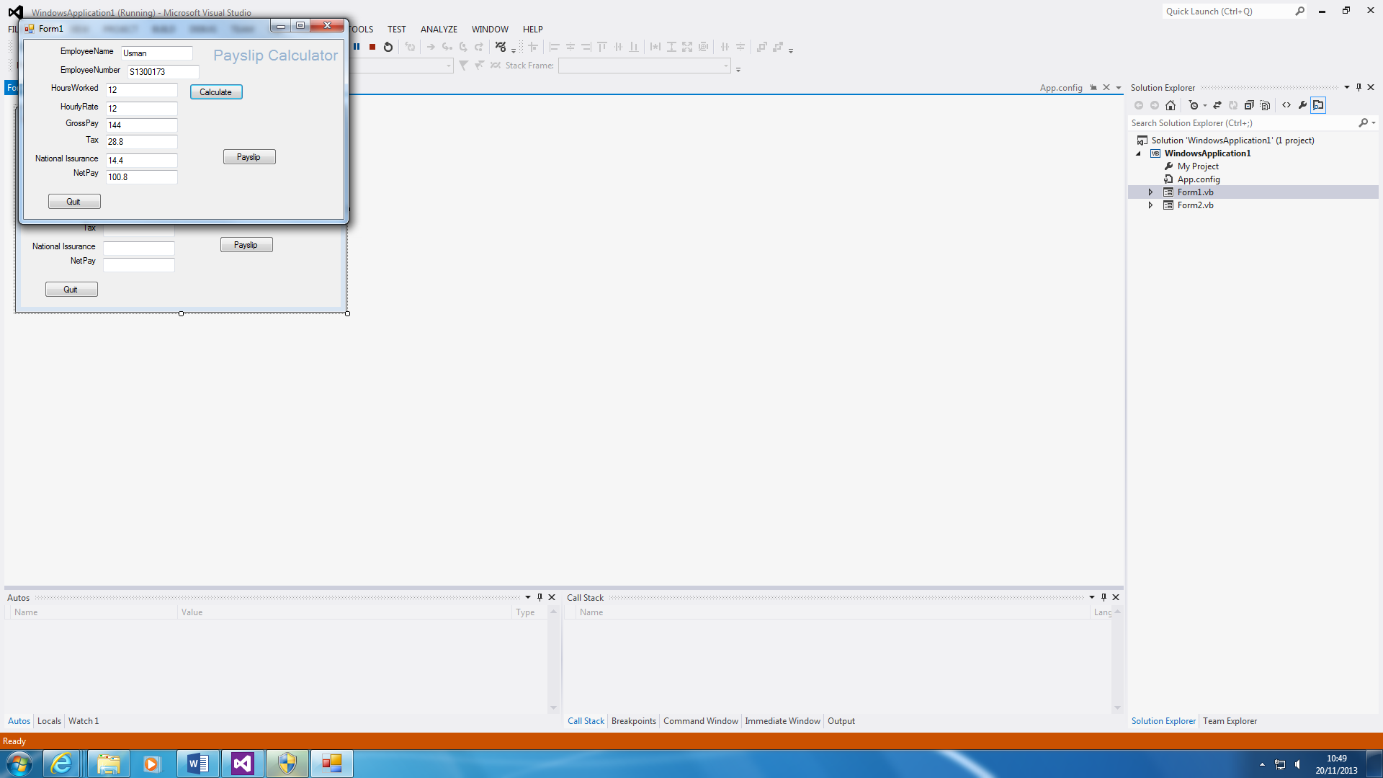

I am going to explain why I chose the data types to be appropriate. I have chosen real for most of the variable names, because most of them give answers as decimals. For example, 10% of any number would give a decimal such as 10% of 144 is 14.4.

**Integer** for EmployeeName is all numbers. They will be a lot of employees so you will need to number them from 1-10 to make it easier. This will be easier and appropriate to use.

**Character** for EmployeeName cannot be anything else except words. This is the name of the employee, but if someone has the exact name of the employee. The employee name would come in useful to identify which employee is which.